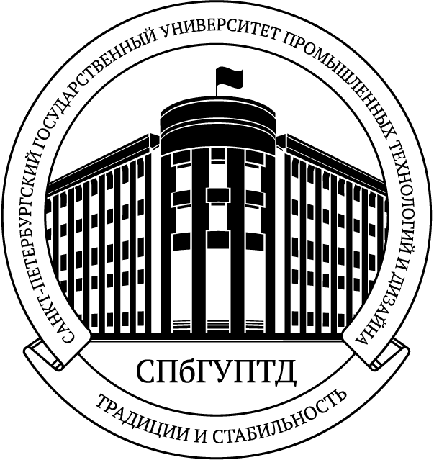
Ministry of Science and Higher Education
of the Russian Federation

Saint Petersburg State University of Industrial Technologies and Design
(SPbSUITD)
__________________________

18, Bolshaya Morskaya Str., Saint-Petersburg,
PO 191186, Russian Federation
Tel./Fax +7 (812) 315-12-10; +7 (812) 315-05-01
E-mail: international@sutd.ru
http://www.sutd.ru

_______________ № ______________________

